Thunderstorm Facts and Lore
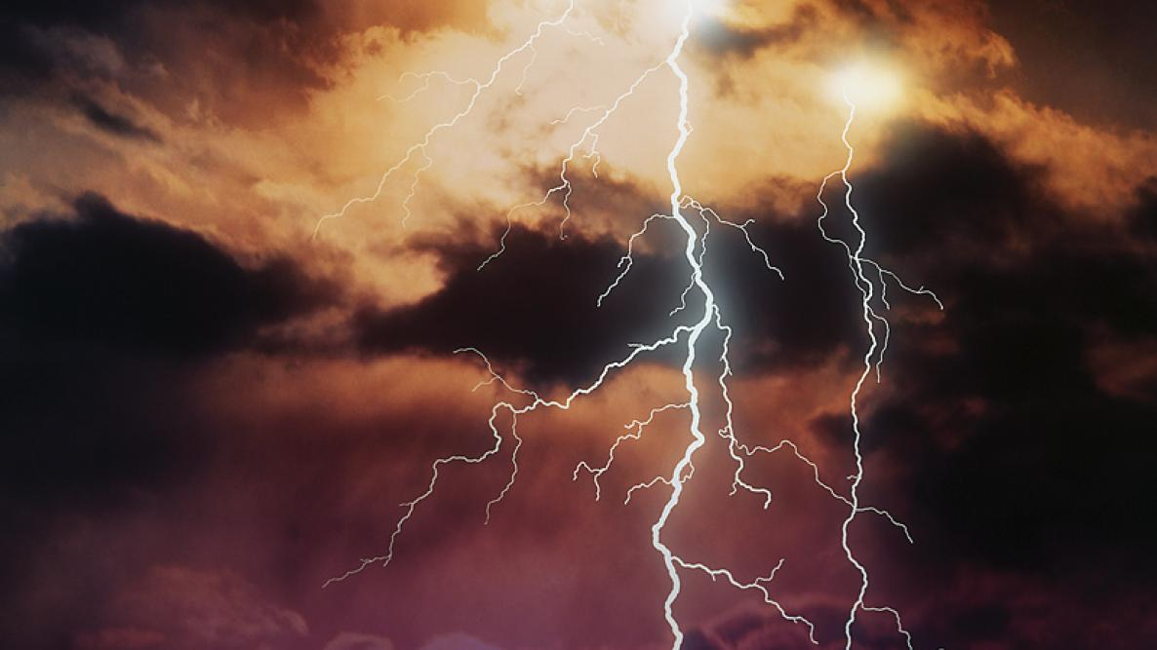

With July comes nature’s fireworks—thunderstorms! How is thunder formed? How far away is lightning? Let’s look at some thunder lore and how thunder is born.

What is Thunder?
Thunder is born in the instant when the return lightning stroke leaves the earth and spears upward through the channel of ionized air. The channel is viciously expanded outward and bursts in the sonic shock wave that reaches up as a thunderclap. This initial sound is followed by a rumble as the thunder echoes through the sky.

How Far Away is Lightning?
The sound of thunder always reaches us after we see the lightning flash because light rays travel at 186,282 miles a second while sound waves (the speed of which varies with such factors as temperature) lope along at somewhere between 1,000 and 1,100 feet or so per second. This difference in speed enables us to tell just how far away the lightning is striking. All that needs to be done is to count the seconds between the flash and the initial thunderclap. For every 5 seconds that elapse, the lightning is about 1 mile away.

The "Shocking" Secrets of Lightning
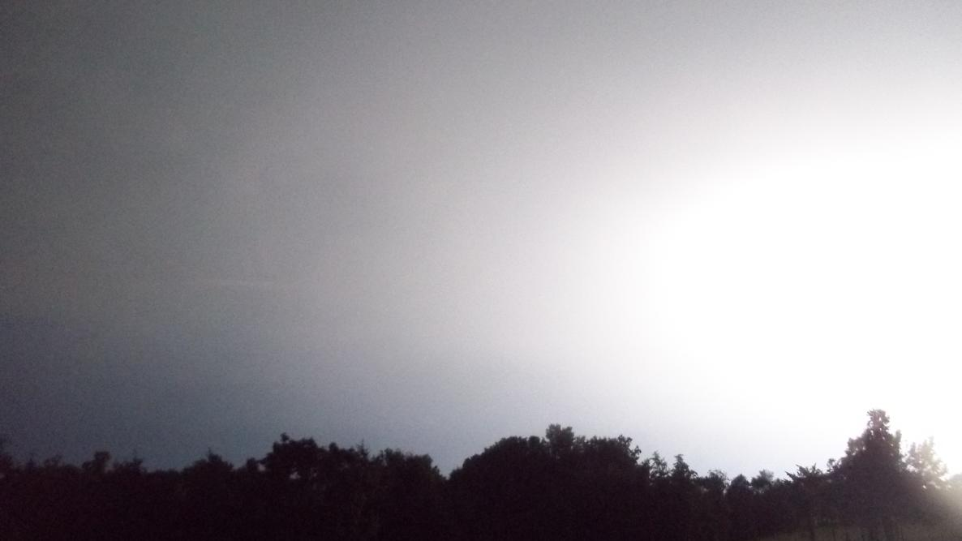

If you’ve ever been close to a lightning strike, you know just how powerful a stroke of lightning is.
With temperatures five times hotter than the surface of the Sun and enough electricity to briefly power a city, one of Zeus’s thunderous bolts is clearly something beneath which you don’t want to find yourself.
- Surprisingly, only about 10 to 20 percent of all lightning within a storm is the lightning that we see. In fact, the vast majority occurs within the storm cloud rather than between the cloud and the ground.
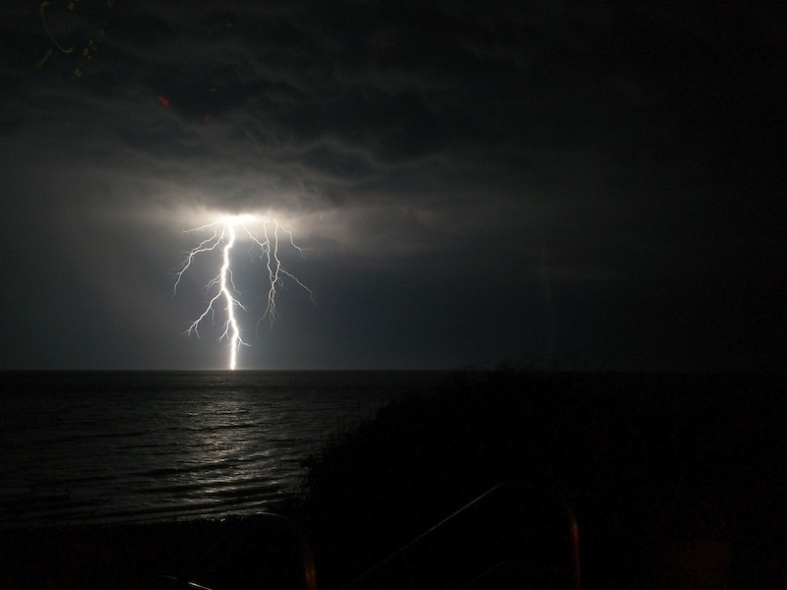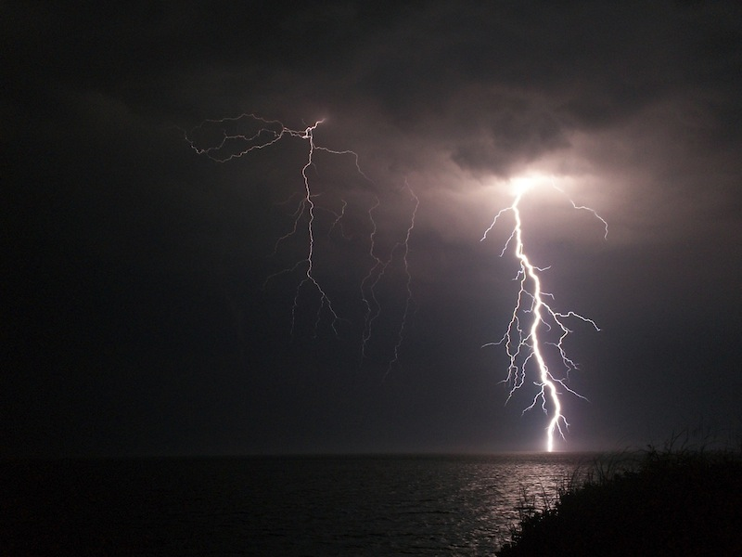
Above photos show lightning during a severe thunderstorm over Cape Cod, Massachusetts, on June 24, 2013. Credit: Matthew Cappucci.
Lightning is Mother Nature’s natural balancing act between charged objects. In this case, friction between raindrops, ice crystals, and other cloud-borne particles results in a negative charge building up within the base of the cloud as “outer-shell” electrons find their way to this region. As the charge grows in the cloud, it begins to become nearly too much for the cloud to handle; a bolt of lightning flashes between the cloud—negative—and the ground—positive by comparison—as a means to equalize and balance the opposite charges.
Every time lightning strikes, hundreds of millions of volts (a measure of the difference in charges between two objects) and nearly 20,000 amperes (a measure of the quantity of current flowing through a lightning bolt, exerting energy dependent on the voltage) course through the pulsating vein of power.
The “flickering” appearance of lighting is due in part to the sheer quantity of raw power being exerted through it; so much electricity passes through a bolt of lightning that multiple “trips” are required in order for all of this power to be exchanged successfully.
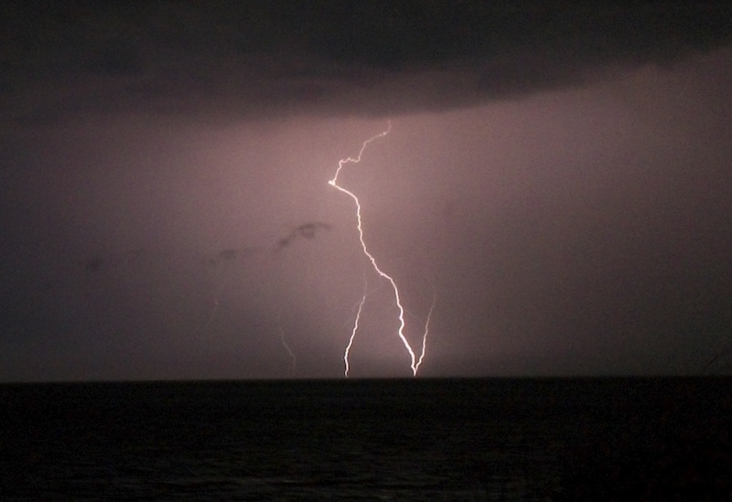
An instance of ground-to-cloud, or “upward” lightning during a severe thunderstorm over Cape Cod, Massachusetts, on June 24, 2013. Credit: Matthew Cappucci.
- A common misconception of lightning is that it travels downward from the base of a cloud, with its force being recognized once it reaches the ground. In reality, however, such is not the case. It travels both ways. The downward-reaching branch is met by an skyward-bound “upward streamer.” Once these two segments of the bolt meet, a path has been formed for the incredible power of a lightning strike to be achieved. It can be thought of in essence as a microcosm of the Transcontinental Railroad: Crews from both coasts worked in building track to eventually meet in the middle, at which point thousands of passengers were able to move across the length of track spanning the nation. In this way, a lightning bolt is analogous to a “railroad for electrons.”
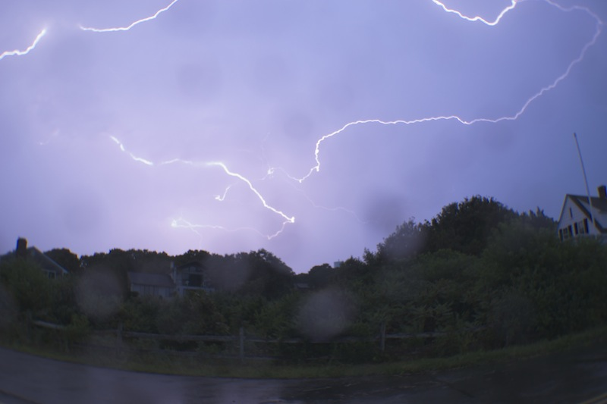
Lightning during a severe thunderstorm over Cape Cod, Massachusetts, on September 1, 2013. Credit: Matthew Cappucci.
But not all lightning bolts are quite as simple; oftentimes, one lightning bolt can trigger a series of consequent electrical disturbances that ripple across all levels of the atmosphere.
- “Superbolts,” which seem a myth coming from ancient folklore and legends, are a legitimate phenomenon regarded as one of the most dangerous types of all lightning. A “superbolt” describes an extreme bolt of electricity emanating from the positively charged top of the cloud, harnessing three to as much as 100 times the power of an ordinary lightning bolt.
What makes these bolts so dangerous, however, is their tendency to strike upward of 10 miles away from a thunderstorm. These so-called “bolts from the blue” have been known to strike on perfectly sunny days featuring crystal-clear skies, with little more than the barely audible rumble from a distant thunderhead. The power of these bolts has sparked dozens of forest fires that oftentimes remain unextinguished by rains that fall too far away to be of any assistance. Superbolts are known for their remarkable power. It should come as no surprise that a superbolt once threw a 600-pound church belfry several hundred yards in Michigan. While statistically less than one out of every 100,000 lightning strikes is from a “superbolt,” their effects can be startling.
On May 21, 2012, residents of Tulsa, Oklahoma, awoke to about 15 seconds of earthquake-like shaking, intense thunder, and resounding booms shortly after 3:30 A.M. The National Weather Service later identified the culprit as a “superbolt,” which created what some referred to as a “thunderquake” strong enough to set off car alarms within a half-mile radius of the location of the strike. One eyewitness told local news media that their bed was shifted 4 feet due to the shaking associated with the bolt.
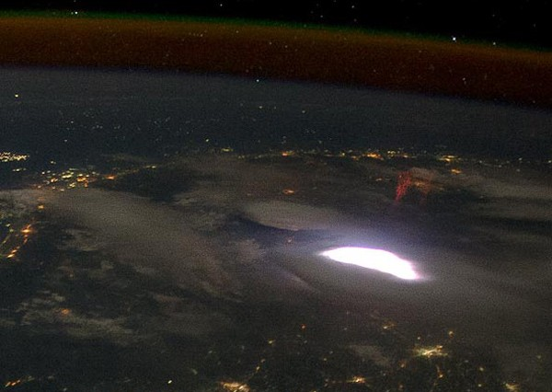
A red sprite photographed above a severe thunderstorm by NASA scientists aboard the International Space Station.
- The same storms that produce superbolts frequently have enough energy to produce other types of lightning as well; red sprites and blue jets both form in the region miles above a severe thunderstorm, close to space, while ball lightning is regarded by scientists as one of the most curious forms of lightning to date.
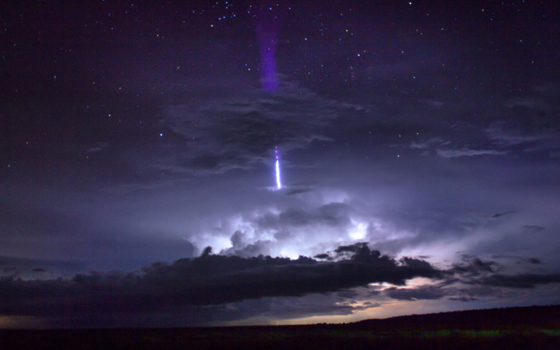
A ‘giant blue jet’ captured by Thijs Bors in Australia’s Northern Territory during a vigorous thunderstorm.

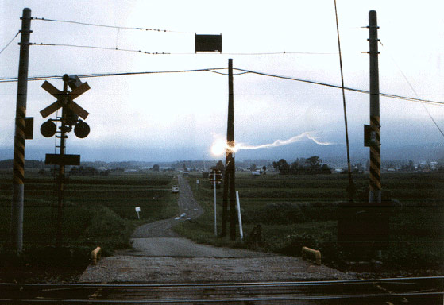
One of the only known photographs of ball lightning in existence, snapped in Nagono, Japan in 1988; photographer unknown.
So, the next time you find yourself faced by a thunderstorm, perhaps take a moment to watch the show; after all, it’s like Mother Nature’s way of treating us to her own Independence Day fireworks display.

Lightning Bolts: Types of Lightning
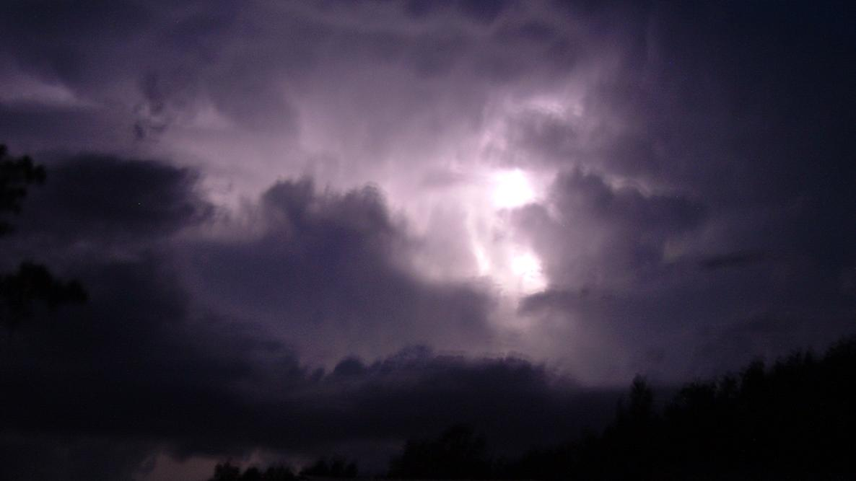
Caption
Late evening western sky with distant storm.

During the summer thunderstorm season, not all of the fireworks you see are manmade. The skies will be filled with light—and many types of lightning!

What is Lightning?
Lightning starts with the collision of ice crystals, slush, and rain in a thundercloud. The slush and rain that develop near the bottom of a cloud build up a negative charge, while the tiny ice crystals carried to the top of the cloud become positive. When a channel of air (known as a “step leader”) opens up between the two layers, a near-instantaneous discharge of electrons and ions flows from one side to the other. This is what we know as lightning. The heat given off by the flow of electrons makes the surrounding air molecules explosively expand, causing a flash of light and a shock wave (thunder). As my previous post on lightning noted, those lights are spectacular electric sparks.
The discharge usually flows within or between clouds, but about 25% of the time, it hits the ground. Sometimes when the discharge stays in the air, the lights it forms are very strange. A few of these are known as red sprites, blue jets, and even elves, as pictured below.
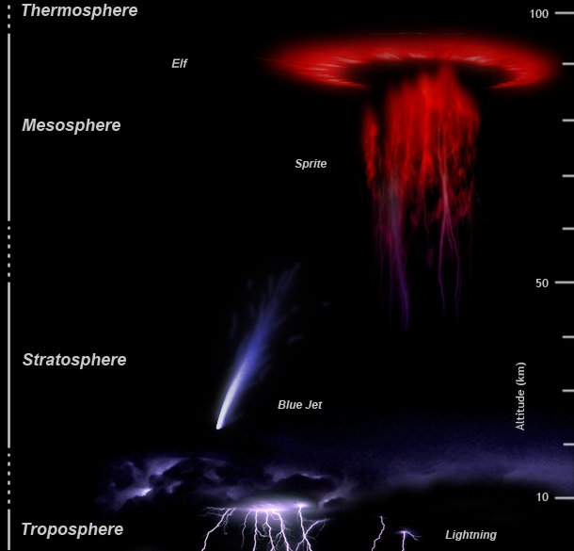
There are different types of lightning—some quite weird! Source: NOAA
Most lightning flashes in the air, rather than striking the ground. You see the clouds light up and hear the thunder.
- The majority of these flashes are “heat lightning” with the electricity flowing between the top and bottom of a cloud, making the whole thundercloud glow.
- The next most common is the “anvil crawlers” and the electricity sparks from cloud to cloud.
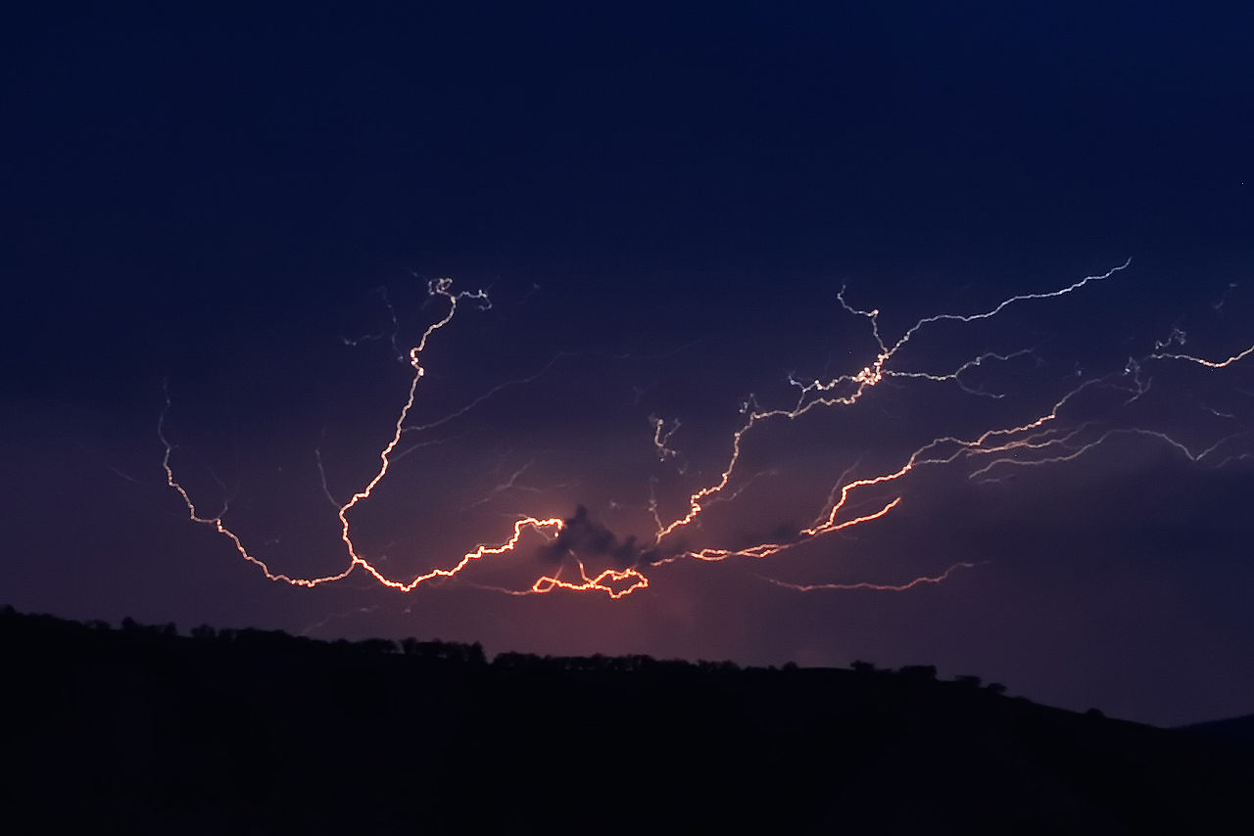
Three fourths of all lightning stays in the sky, even soaring up toward space. Source: Wikipedia
- Then there are sparks that flare straight up towards space. For more than two hundred years, scientists dismissed these types of lightning as nonexistent. Then, on July 6, 1989, scientists from the University of Minnesota accidentally captured the first image of the glowing red lightning dancing high in the air. They named the “nonexistent” lightning a sprite, after fairy-tale air sprites.
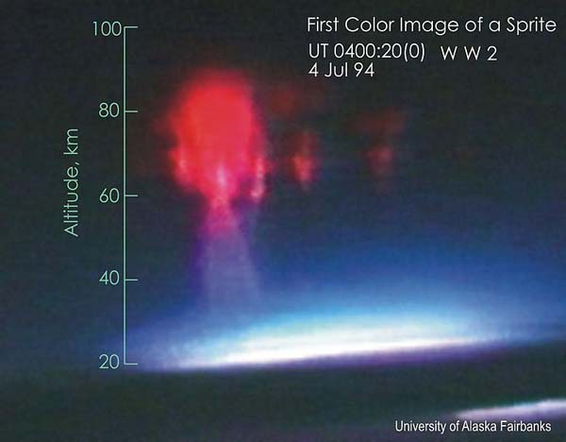
A circle of red sprites dancing 50 miles high in the sky. Source: Wikipedia
Since then other forms of lightning have been found and given exotic names—blue jets, red sprites, elves, trolls and even tiny gnomes. The area above storms can get very strange.
Summer is the season to see these rare forms of sky lightning (especially in July). Some of the best sightings are in the Midwest and Great Plains. So go outside and look up—the skies are filled with “magical” lights.

Lightning Storms: 10 Safety Tips You Should Know
Subhead

Lightning facts and fiction!
James J. Garriss

Lightning may be awesome to watch, but it can also be dangerous—even deadly. Did you know that lightning strikes more than 40 to 50 times a second during June, July and August? So, summer is a good time to learn more about nature’s light shows and familiarize yourself with 10 basic lightning safety rules. Know your “flash” facts from fiction.

For example, if that resulting number was 5 seconds, then the lightning struck 1 mile

Predicting Lightning
First, know that every thunderstorm produces lightning.
Warm, humid summer days are the times when thunderstorms are most likely to develop, especially in the afternoons, as the sun heats the air and heat rises into the atmosphere. Watch as those puffing cumulus clouds start to form. As they build, they’ll start to “tower” vertically upward, and likely to develop into a thunderstorm.
Flash Fact: If your hair stands up in a storm, it could be a bad sign that positive charges are rising through you. Get yourself indoors immediately.
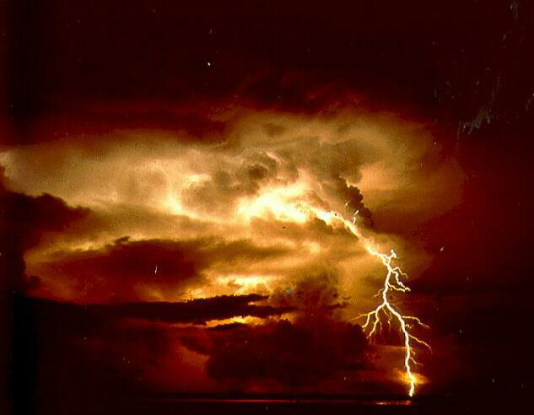Summertime is lightning season. Source: NOAA

Can Lightning Kill You?
Surprisingly, lightning is one of the leading weather-related causes of death and injury in the United States. 3,696 deaths were recorded in the U.S. between 1959 and 2003) or cause cardiac arrest.
What Are the Odds of Being Struck by Lightning?
The odds of being killed by lightning is 1 in 700,000. But the odds of being struck in your lifetime is 1 in 3,000.
About 70% of those struck by lightning suffer serious long-term effects such as severe burns, permanent brain damage, memory loss, and personality change.
But some places are more dangerous than others.
- Kifuka in the African Democratic Republic of the Congo averages 410 lightning strikes per square mile every year.
- In North America, the champion is the Tampa-Orlando area with 91 flashes per square mile.
Even then, statistics show that not all people face the same risks. Little old ladies are safe, but guys between the ages of 20 and 30 seem to be lightning rods.
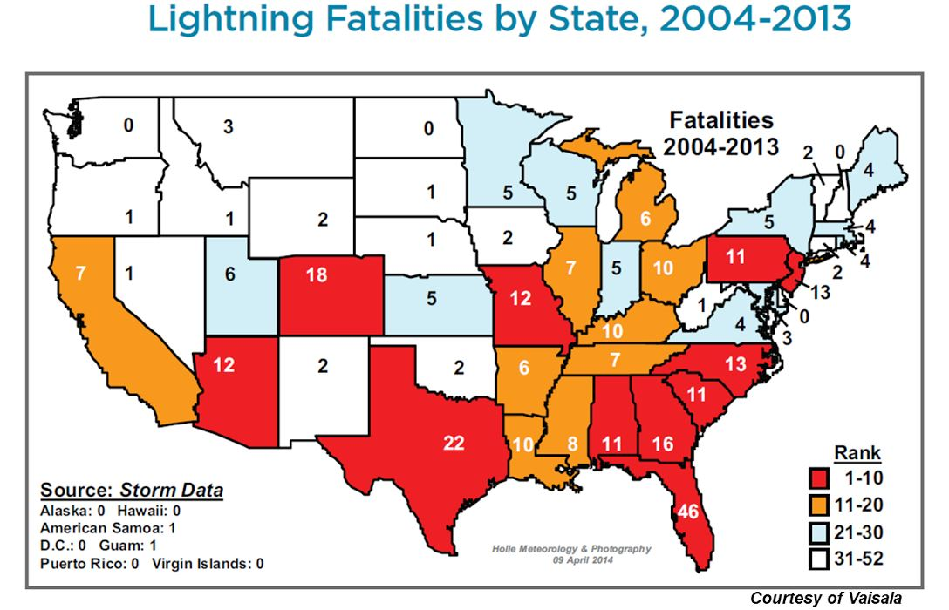
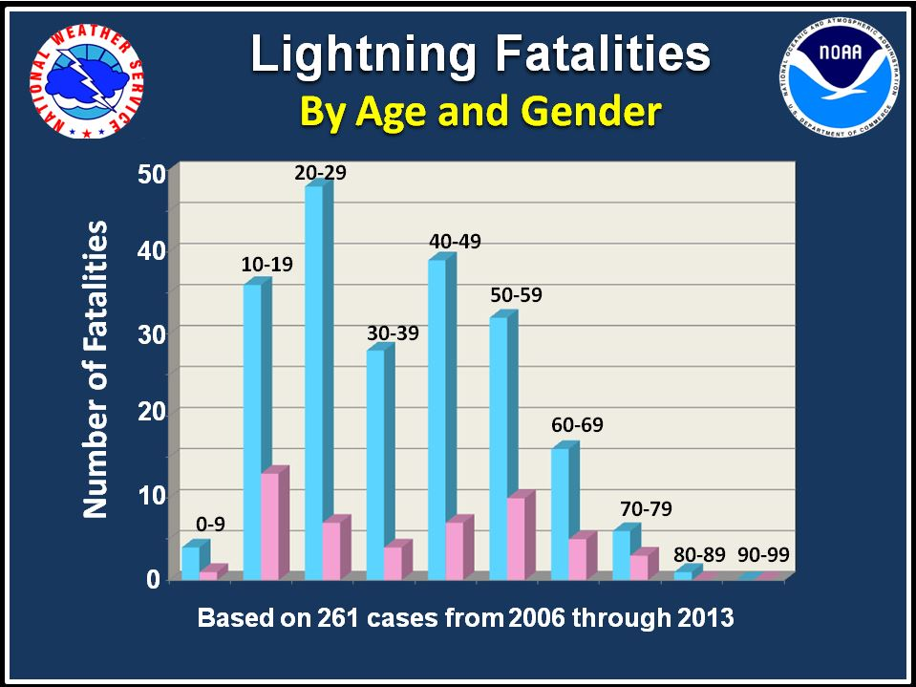
If you are a young man in Florida, lightning is not your friend! Source: NOAA

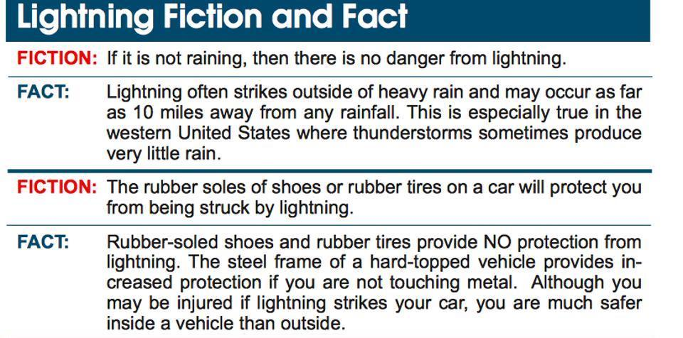

10 Lightning Facts and Fiction
The rules for safety in lightning storms are mostly common sense but you may find a few surprises here. Separate the facts from the fiction.
- Do not hide under a tall tree. Being under a tree is just about the worst thing you can do and the second leading cause of lightning casualities. If lightning does hit the tree, there’s the chance that a “ground charge” will spread out from the tree in all directions. Also, don’t touch anything metal outside—such as a fence or bike—as metal can conduct the electricity.
- If no shelter is available, crouch low, with as little of your body touching the ground as possible. Lightning causes electric currents along the top of the ground that can be deadly over 100 feet away. Do not lie flat on the ground. While lightning hits the ground, it sends deadly electrical currents in all directions. By lying down, you may even be more likely to be electrocuted because you’re providing more surface area.
- Cars are relatively safe shelters and will likely protect you. Make sure the windows are shut. Myth: The car isn’t safe because of rubber tires but because the metal roof and sides divert lightning around you. Convertibles and motorcycles offer no lightning protection.
- Stay out of water! Swimming is very dangerous. Wet bodies are a channel for electrical discharge and also water is a good conductor of electricity.
- Find shelter quickly. “When The Thunder Roars, Go Indoors” is a common warning. A house or large structure is the safest place you can be during a storm. Note small structures (such as an athletic hut or metal sheds) are only meant to protect from rain and sun and not designed to be lightning-safe with mechanisms for grounding from the roof to ground.
While being in your home or a large shelter is safest, you may be surprised to discover that one-third of lightning strike injuries still happen indoors! There are a few tips to remember when you are waiting out a storm inside:
- Stay away from windows and doors in your home, especially metal doors and frames. As tempting as it is, you may not want to stand next to a big window watching a huge lightning storm.
- Avoid concrete walls or flooring which often have metal rods or framing for support. Lightning can travel through any metal wires or bars in concrete walls or flooring.
- Stay away from plumbing and water indoors during a storm. Metal piping conducts electricity. Never take a bath or shower during a thunderstorm.
- Don’t get near electrical equipment like televisions, stereos, wires, TV cables, and “smart” electronics during a big storm. Don’t use a corded phone (cellular or cordless phones are fine). Talking on the telephone is the leading cause of lightning injuries inside the home!
- Surge protectors do not protect against direct lightning strikes. Unplug equipment such as computers and televisions or anything connected to an electrical outlet. Lightning can travel through electrical systems, radio and television reception systems, and any metal wires or bars. (These items must be installed in conjunction with a lightning protection system to provide whole house protection.)
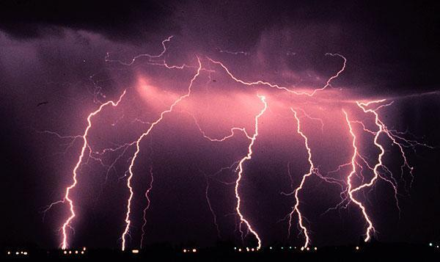
Credit: NASA

